Nursing eBooks on EBSCO eBooks

- Go to the Wallace State Community College website. https://www.wallacestate.edu/index.html

- Click on the Library tab on the Wallace State website to access the WSCC Library webpage.


- On Wallace State Library website, scroll down to select the Books and eBooks tab or the Online Databases tab to access EBSCO eBooks.



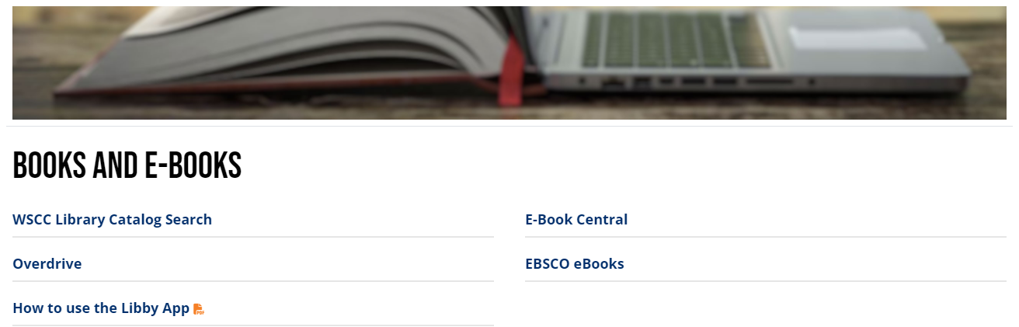
- Under the Books and E-Books tab, click on EBSCO eBooks to access the EBSCO eBook collection. Under the Online Databases tab, click on EBSCO eBooks to access the EBSCO eBook collection.
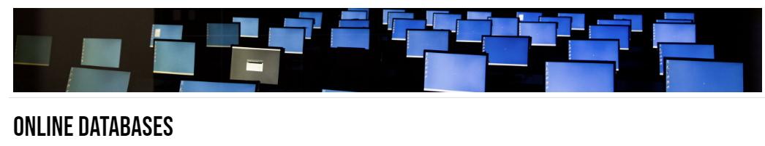
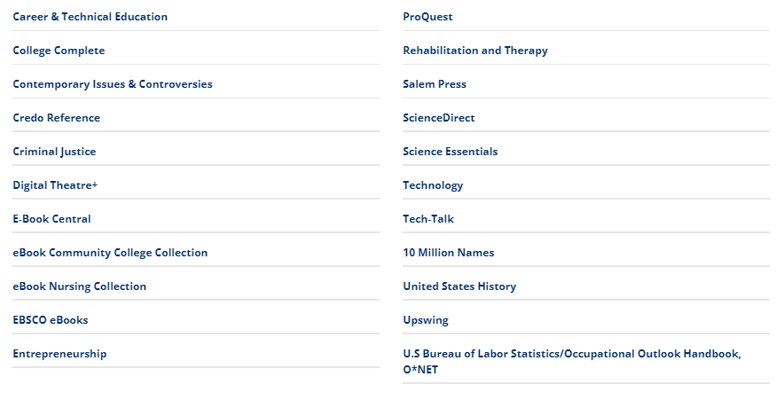

- In EBSCO eBooks, type in the subject that you would like to learn more information about in the search bar located at the top of the webpage.
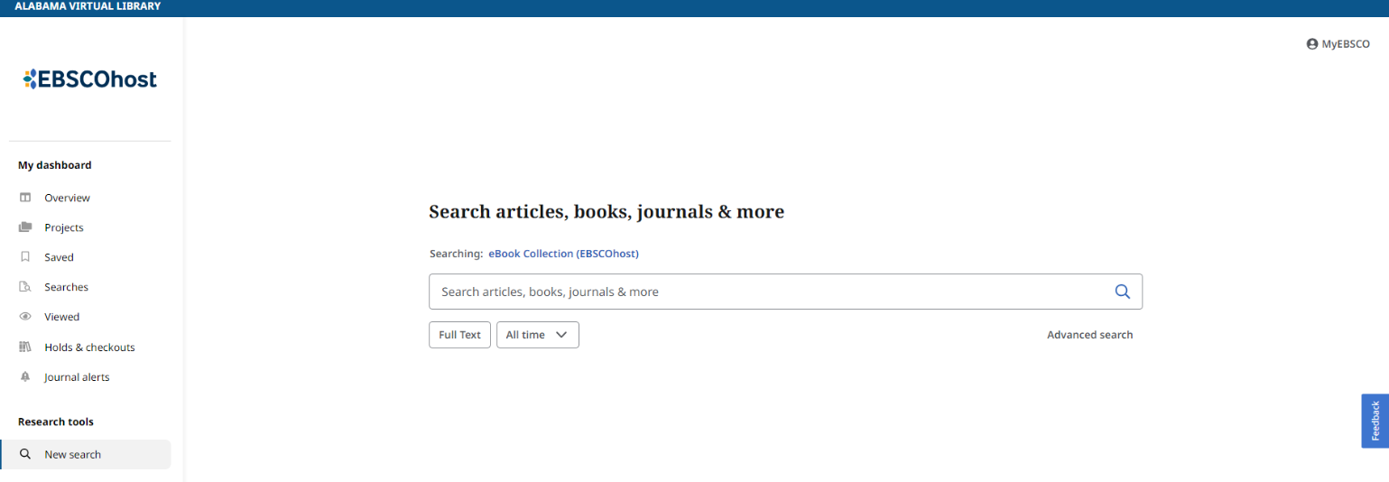

- For example, if you wanted to search for oncology eBooks, you would type oncology into the search bar, and it will pull up all the available oncology eBooks on the EBSCO database. This database includes eBook holdings purchased from EBSCO and eBook holdings in the EBSCO database.
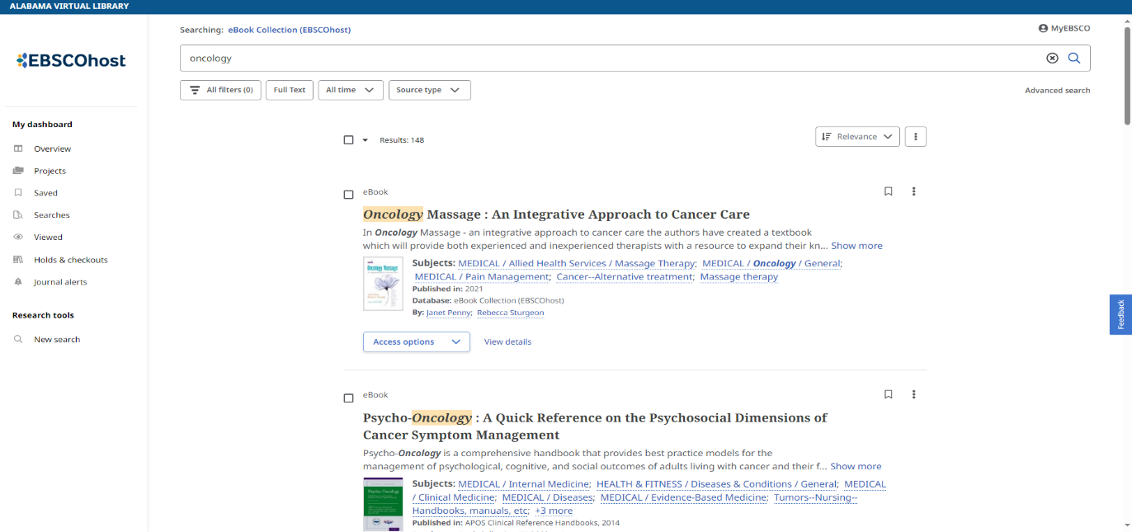

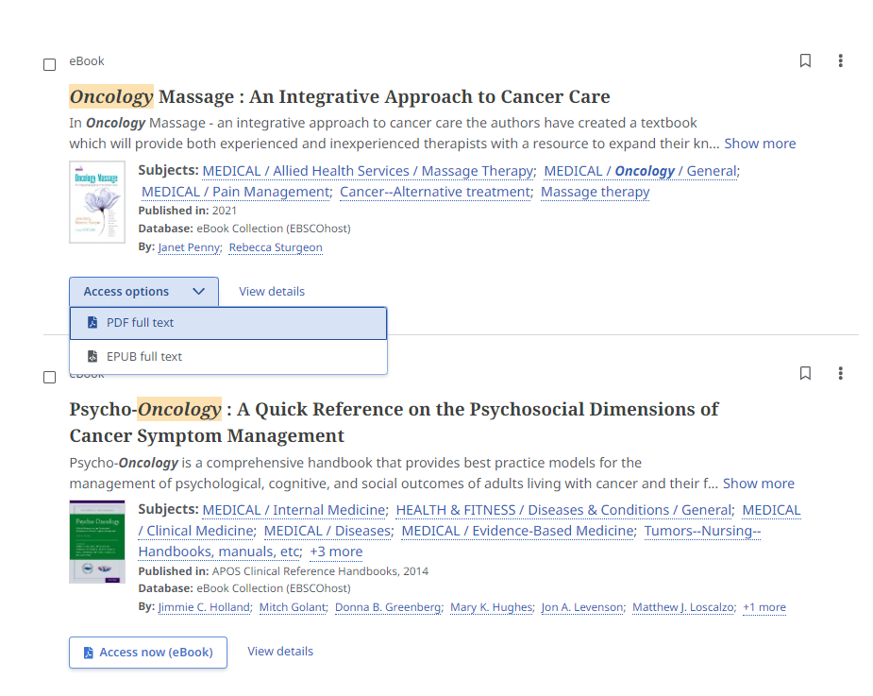
- On EBSCO eBooks, each eBook gives you different access options on how you want to access the eBook like access now to read the eBook or whether you want the eBook in PDF full text or EPUB full text.

